**URDF Rod-plate End Effector**

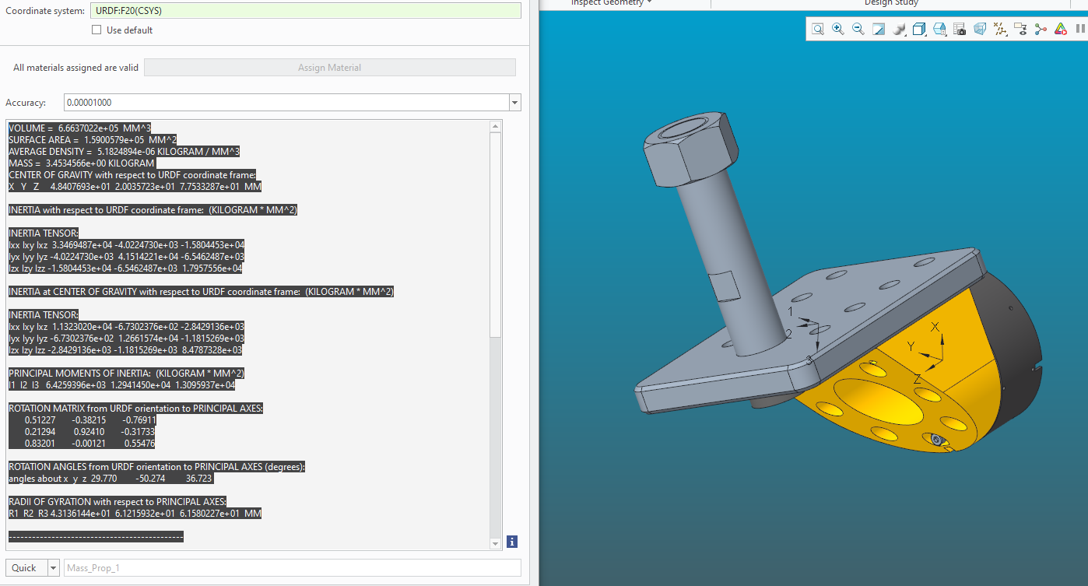VOLUME = 6.6637022e+05 MM^3

SURFACE AREA = 1.5900579e+05 MM^2

AVERAGE DENSITY = 5.1824894e-06 KILOGRAM / MM^3

MASS = 3.4534566e+00 KILOGRAM

CENTER OF GRAVITY with respect to URDF coordinate frame:

X Y Z 4.8407693e+01 2.0035723e+01 7.7533287e+01 MM

INERTIA with respect to URDF coordinate frame: (KILOGRAM * MM^2)

INERTIA TENSOR:

Ixx Ixy Ixz 3.3469487e+04 -4.0224730e+03 -1.5804453e+04

Iyx Iyy Iyz -4.0224730e+03 4.1514221e+04 -6.5462487e+03

Izx Izy Izz -1.5804453e+04 -6.5462487e+03 1.7957556e+04

INERTIA at CENTER OF GRAVITY with respect to URDF coordinate frame: (KILOGRAM * MM^2)

INERTIA TENSOR:

Ixx Ixy Ixz 1.1323020e+04 -6.7302376e+02 -2.8429136e+03

Iyx Iyy Iyz -6.7302376e+02 1.2661574e+04 -1.1815269e+03

Izx Izy Izz -2.8429136e+03 -1.1815269e+03 8.4787328e+03

PRINCIPAL MOMENTS OF INERTIA: (KILOGRAM * MM^2)

I1 I2 I3 6.4259396e+03 1.2941450e+04 1.3095937e+04

ROTATION MATRIX from URDF orientation to PRINCIPAL AXES:

0.51227 -0.38215 -0.76911

0.21294 0.92410 -0.31733

0.83201 -0.00121 0.55476

ROTATION ANGLES from URDF orientation to PRINCIPAL AXES (degrees):

angles about x y z 29.770 -50.274 36.723

RADII OF GYRATION with respect to PRINCIPAL AXES:

R1 R2 R3 4.3136144e+01 6.1215932e+01 6.1580227e+01 MM

**Tmatrix wrist-pitch to ROD-plate**

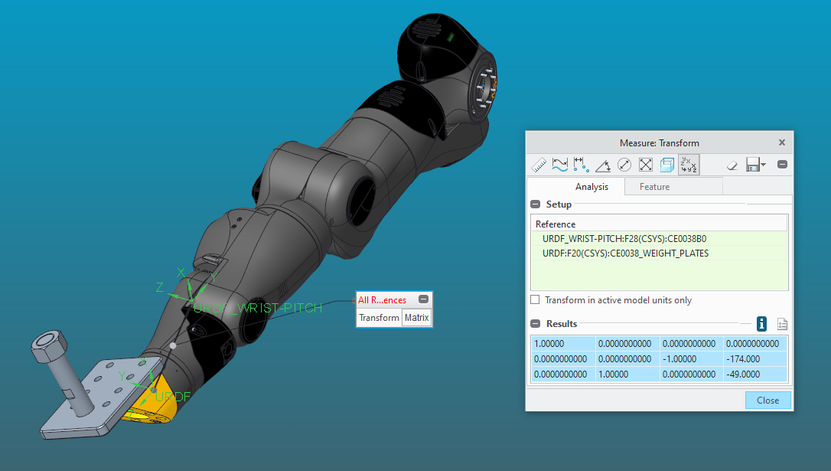

1.00000 0.0000000000 0.0000000000 0.0000000000

0.0000000000 0.0000000000 -1.00000 -174.000

0.0000000000 1.00000 0.0000000000 -49.0000